22.2: a) 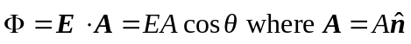
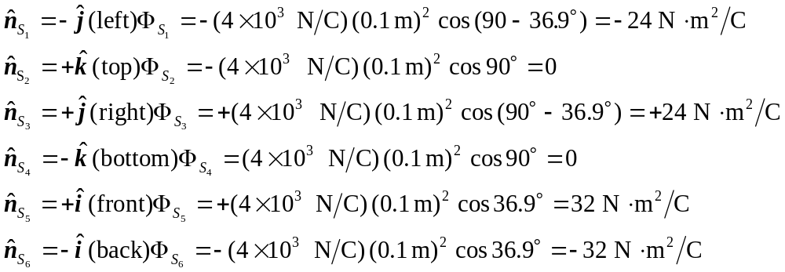

b) The total flux through the cube must be zero; any flux entering the cube must also leave it.

